Lecture # 01
Course: Nanotechnology & Nanostructures
Instructor: Dr. Zohra Kayani

Nanoderivatives:
The term nanoderives from the Greek word for dwarf. It is used as a prefix for any unit such as a second or a meter, and it means a billionth of that unit. Hence, a nanometer (nm) is a billionth of a meter, or 10⁻⁹ meters.
Nanotechnology:
Nanotechnology is the engineering (manipulation) of matter on an atomic, molecular, and supramolecular level (the science of working with atoms and molecules to build devices (such as robots) that are extremely small.
Nanoscience:
Nanoscience is the study of extremely small things and can be used across all the other scientific fields, such as chemistry, biology, physics, materials science, and engineering.

What is so special about nanotechnology?
- First, it is an incredibly broad, interdisciplinary field (physics, chemistry, materials science, biology, mechanical and electrical engineering, medicine, and their collective knowledge).
- It is the boundary between atoms and molecules and the macro world, where ultimately the properties are dictated by the fundamental behavior of atoms.
- It is one of the final great challenges for humans, in which the control of materials at the atomic level is possible.

What is so different and special about nano?

- There is more than one answer to that question of which the most obvious is that of surface area.
- Almost all properties of the thin layer of atoms that lie in the surface or interface of things behave in a different way than those in the interior i.e. surfaces have their own properties.
- At the macro scale, the fraction of atoms that lie on the surface is minuscule. On the micron scale it is still tiny. But approach the nanoscale and it takes off (Figure). The combination of small scale and a large fraction of “surface” atoms give a property set that can be very different from that of the bulk.
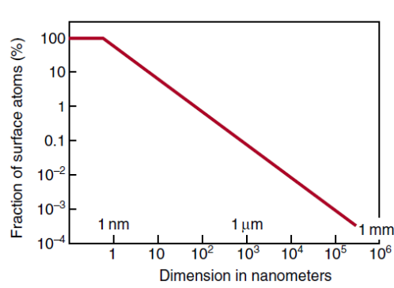

Properties of Nanomaterials :
They have different physical, mechanical, thermal, electrical, magnetic, optical, and, above all, chemical properties than those of the bulk:
- They can offer strong wear-resistant coatings;
- They can change the ways in which heat and electricity are conducted;
- They have the ability, through their electrical and magnetic behavior, to store information.
- They distribute drugs in the human body via their chemical behavior to catalyze chemical reactions.

Composition of Nanomaterials:
Nanomaterials may
- Be made of metals, ceramics, or polymers.
- Be amorphous or crystalline (single crystalline or polycrystalline).
- Be composed of single or multi-chemical elements
- Exhibit various shapes and forms
- Exist individually (powder), incorporated into a matrix (solution, colloid, suspension or composites) or in multilayer structures.

Classification of Nanomaterials
Nanomaterials are materials that have structural components smaller than 1 micrometer in at least one dimension. Nanoparticles are particles with at least one dimension smaller than 1 micron and potentially as small as atomic and molecular length scales (~0.2 nm).
In ISO/TS 80004, nanomaterial is defined as a "material with any external dimension in the nanoscale or having internal structure or surface structure in the nanoscale", with nanoscale defined as the "length range approximately from 1 nm to 100 nm". This includes both nano-objects, which are discrete pieces of material, and nanostructured materials, which have internal or surface structure on the nanoscale; a nanomaterial may be a member of both these categories.
The nanomaterial class of materials is extremely broad because it can include all the classes (metals, ceramics, polymers, composites, electronic materials, biomaterials) of materials, provided they are composed of a structural component at the nanoscale or they exhibit one of the dimensions at the nanoscale. Nanomaterials are classified according to their dimensions and the distance x, y, and z represent dimensions below 100 nm. The procedure of the classification by dimensions allows nanomaterials to be identified and classified in a 3-D space.
- zero-dimensional (0-D)
- one-dimensional(1-D)
- two-dimensional (2-D)
- three-dimensional (3-D)
This classification is based on the number of dimensions, which are not confined to the nanoscale range (<100 NM).

Zero-dimensional Nanomaterials:
Zero-dimensional (0-D) nanomaterials are materials in which all the dimensions are measured within the nanoscale (no dimensions, or 0-D, are larger than 100 nm). The most common representation of zero-dimensional nanomaterials are nanoparticles and quantum dots. These nanoparticles can:
- Be amorphous or crystalline (single crystalline or polycrystalline)
- Be composed of single or multi-chemical elements
- Exhibit various shapes and forms
- Exist individually or incorporated in a matrix
- Be metallic, ceramic, or polymeric
One-dimensional Nanomaterials:

One-dimensional (1-D) nanomaterials are materials that have one dimension that is outside the nanoscale. 1-D nanomaterials have needle like shaped structures. One-dimensional nanomaterials include nanotubes, nanorods, and nanowires. These 1-D nanomaterials can be:
- Amorphous or crystalline (Single crystalline or polycrystalline)
- Chemically pure or impure
- Standalone materials or embedded within another medium
- Metallic, ceramic, or polymeric
Two-dimensional Nanomaterials
Two-dimensional nanomaterials (2-D) are materials in which two of the dimensions are not confined to the nanoscale. As a result, 2-D nanomaterials exhibit plate like shapes. Two-dimensional nanomaterials include nanofilms, nanolayers, and nanocoatings. These
nanomaterials can be:
- Amorphous or crystalline
- Made up of various chemical compositions
- Used as a single layer or as multilayer structures
- Deposited on a substrate
- Integrated in a surrounding matrix material
- Metallic, ceramic, or polymeric

Three-dimensional Nanomaterials
Three-dimensional nanomaterials (3-D) are also known as bulk nanomaterials. Bulk nanomaterials are materials that are not confined to the minuscule in any dimension. These materialsare thus characterized by having three arbitrarily dimensions above 100 nm. The reason for the continued classification of these materials as nanomaterials is despite their non nanoscale dimensions, these materials possess a nanocrystalline structure or involve the presence of features at the nanoscale. In terms of nanocrystalline structure, bulk nanomaterials can be composed of a multiple arrangement of nanosize crystals, most typically in different orientations.
With respect to the presence of features at the nanoscale, 3-D nanomaterials can contain dispersions of nanoparticles bundles of nanowires, and nanotubes as well as multi nanolayers. Three-dimensional nanomaterials can be:
- Amorphous or crystalline
- Chemically pure or impure
- Composite materials
- Composed of multinanolayers
- Metallic, ceramic, or polymeric

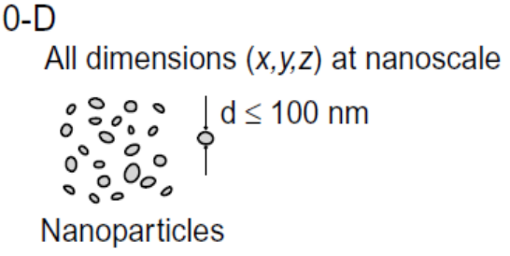  Quantum dots | 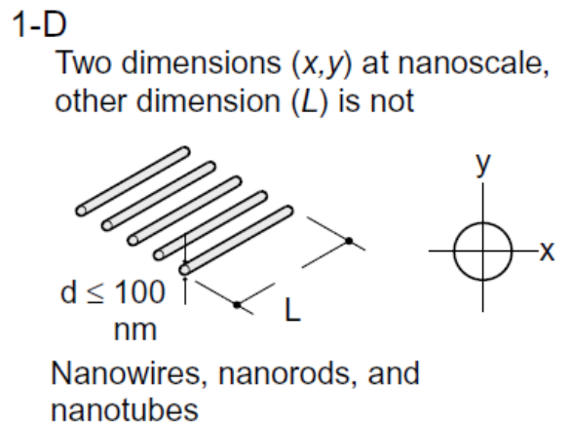
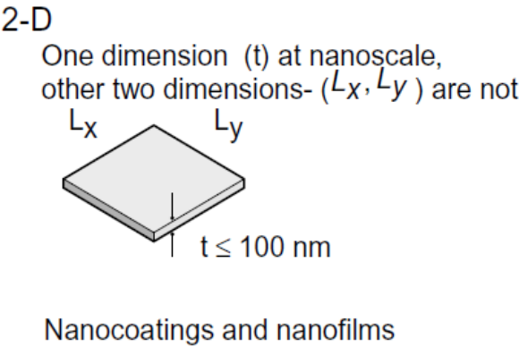 | 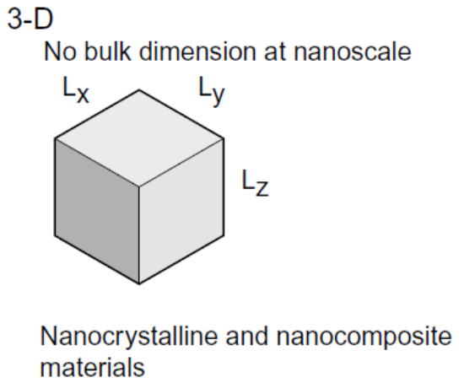
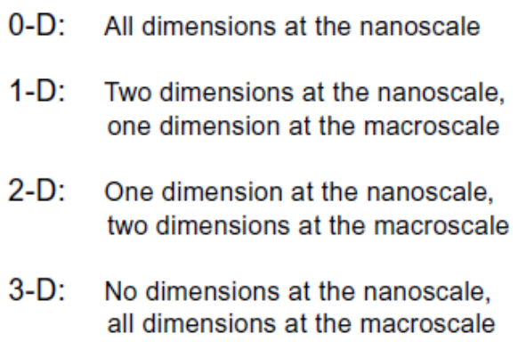 | 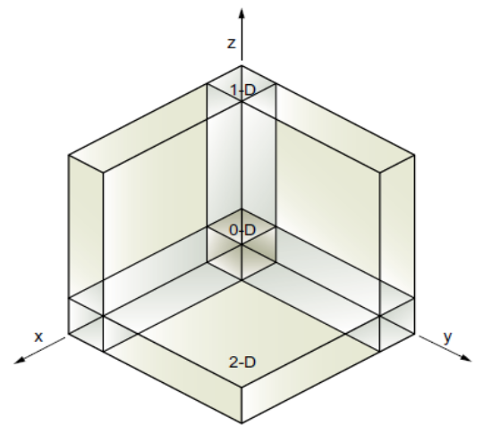

Classification of Nanomaterials, The Four Main Types of Intentionally Produced Nanomaterials

Background
There are many types of intentionally produced nanomaterials, and a variety of others are expected to appear in the future.

Types of Nanomaterials
For the purpose of this article, most current nanomaterials could be organized into four types:
• Carbon Based Materials
• Metal Based Materials
• Dendrimers
• Composites

Carbon Based Materials
These nanomaterials are composed mostly of carbon, most commonly taking the form of a hollow spheres, ellipsoids, or tubes. Spherical and ellipsoidal carbon nanomaterials are referred to as fullerenes, while cylindrical ones are called nanotubes. These particles have many potential applications, including improved films and coatings, stronger and lighter materials, and applications in electronics.

Metal Based Materials
These nanomaterials include quantum dots, nanogold, nanosilver and metal oxides, such as titanium dioxide. A quantum dot is a closely packed semiconductor crystal comprised of hundreds or thousands of atoms, and whose size is on the order of a few nanometers to a few hundred nanometers. Changing the size of quantum dots changes their optical properties.

Dendrimers
These nanomaterials are nanosized polymers built from branch units. The surface of a dendrimer has numerous chain ends, which can be tailored to perform specific chemical functions. This property could also be useful for catalysis. Also, because three-dimensional dendrimers contain interior cavities into which other molecules could be placed, they may be useful for drug delivery.

Composites
Composites combine nanoparticles with other nanoparticles or with larger, bulk-type materials. Nanoparticles, such as nanosized clays, are already being added to products ranging from auto parts to packaging materials, to enhance mechanical, thermal, barrier, and flame-retardant properties.

Unique Properties
The unique properties of these various types of intentionally produced nanomaterials give them novel electrical, catalytic, magnetic, mechanical, thermal, or imaging features that are highly desirable for applications in commercial, medical, military, and environmental sectors. These materials may also find their way into more complex nanostructures and systems. As new uses for materials with these special properties are identified, the number of products containing such nanomaterials and their possible applications continues to grow

Lecture # 02 & 03
Course: Nanotechnology & Nanostructures
Instructor: Dr. Zohra Kayani

Different Routes for Synthesis of Magnetic Nanoparticles
The most common synthesis methods of NPs (Iron-oxide) include:
- Co-Precipitation (Chemical Precipitation)
- Thermal Decomposition
- Microemulsion
- Hydrothermal Synthesis
- Sonochemical Synthesis
- Sol-Gel and forced hydrolysis techniques
- Electrochemical methods
- Aerosol/vapor methods
All routes are directed to the synthesis of high quality of NPs.
In addition, these NPs can also be prepared by the other methods such as electrochemical synthesis, laser pyrolysis techniques, micro-organism or bacterial synthesis etc.
- Co-Precipitation
Co-precipitation is a phenomenon where a solute that would normally remain dissolved in a solution precipitates out on a carrier that forces it to bind together, rather than remaining dispersed.
In the process of co-precipitation, chemical similarities between a carrier and a solute allow the two to bind in some way. The binding pulls the solute out of the solution as the carrier forms crystals or other structures. These can potentially be skimmed out or remove in other ways, leaving a purified solution behind.
There are several ways in which a solute can co-precipitate out of a solution:
- Inclusion, where crystals of a carrier form and the solute finds holes in the crystal matrix to occupy.
- Occlusions, where the carrier completely surrounds the solute, trapping it in the middle of a matrix of crystalline material so it cannot return to the solution.
- Adsorption, where solutes adhere to the surface of a carrier, can occur as well.
Co-precipitation proceeds in two stages. It begins with the redistribution of the carriers between precipitate and medium. In the first stage, the carrier is trapped either on the surface or inside the growing particles. In the second stage of co-precipitation, the concentration of defects within the precipitate decreases and the particles flocculate.
The most conventional method for obtaining oxide NPs is by co-precipitation. This method consists of mixing carrier and solute ions in a 1:2 molar ratio in highly basic solutions at room temperature or at elevated temperature. The size and shape of the iron oxide NPs depends on:
- Type of salt used (such as chlorides, sulfates, nitrates, perchlorates, etc.),
- Carrier and solute ions ratio,
- Reaction temperature,
- PH value,
- nature and concentration of the alkali medium
- Other reaction parameters (e.g. stirring rate, dropping speed of basic solution)
The advantages of co-precipitation reactions are:
- the homogeneity of component distribution,
- the relatively low reaction temperature,
- the fine and uniform particle size with weakly agglomerated particles and
- the low cost.
The disadvantages of co-precipitation reactions are:
- However, these reactions are highly susceptible to the reaction conditions and because of incomplete precipitation of the metal ions, control over the stoichiometry of the precursors is rather difficult to achieve.
- In addition, the co-precipitation reactions are not suited for certain oxides/hydroxides, for instance, in the case of amphoteric systems.

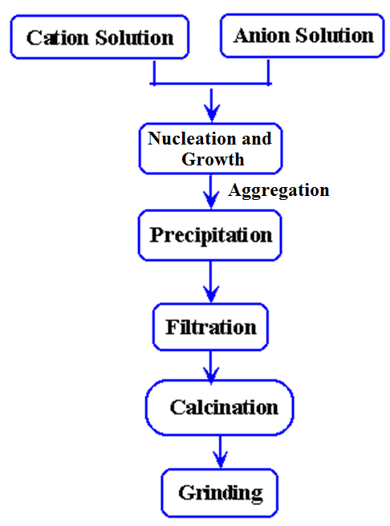
Schematic of Co-precipitation Method
- Thermal Decomposition
Thermal decomposition (thermolysis) is a chemical decomposition caused by heat. The decomposition temperature of a substance is the temperature at which the substance chemically decomposes.
It is a method to produce different chemical compounds and materials using closed- system physical and chemical processes flowing in aqueous solutions at temperatures above 100°C and pressures above 1 atm. The reaction is usually endothermic as heat is required to break chemical bonds in the compound undergoing decomposition. Nano-crystals with smaller size can essentially be synthesized through the thermal decomposition of organometallic compounds in high-boiling organic solvents containing stabilizing surfactants.
The process does not require a size-selection procedure and is readily scaled up for mass production. Although the thermal decomposition method has many advantages for producing highly monodispersed particles with a narrow size distribution.
The advantages of co-precipitation reactions are:
Advantages of the hydrothermal synthesis method include the
- ability to synthesize crystals of substances which are unstable near the melting point.
- and the ability to synthesize large crystals of high quality.
• Ability to synthesize large crystals of high quality.
Ability to synthesize crystals of substances which are unstable near the melting point.
• Ability to synthesize large crystals of high quality.
.
• Ability to synthesize large crystals of high quali
• Ability to synthesize crystals of substances which are unstable near the melting point.
• Ability to synthesize large crystals of high qualit
The advantages of co-precipitation reactions are:
- the high cost of equipment and the inability to monitor crystals in the process of their growth.
- and the resulting NPs are generally only dissolved in nonpolar solvents.

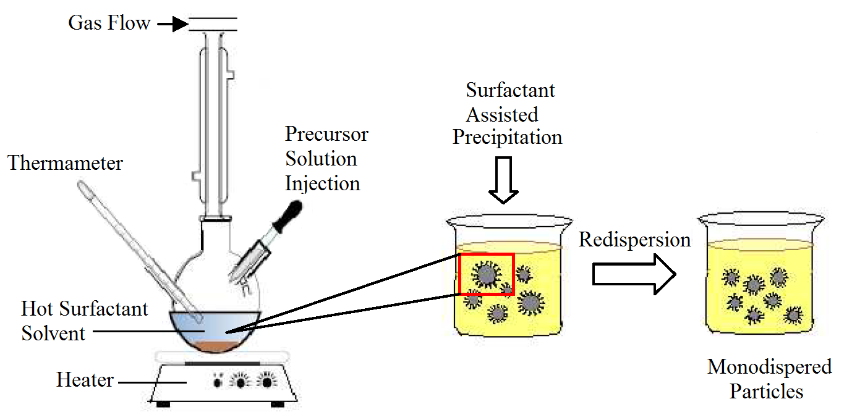

- Microemulsion
Microemulsion is a thermodynamically stable isotropic dispersion of two immiscible phases (water and oil) under the surfactant present, the surfactant molecules may form a monolayer at the interface between the oil and water, with the hydrophobic tails of the surfactant molecules dissolved in the oil phase and the hydrophilic head groups in the aqueous phase.
Hence, the main idea behind the microemulsion technique is simple: two reactants are introduced in two identical microemulsions. After mixing both microemulsions, the droplets collide and interchange the reactants. Then the reaction can take place inside the nanoreactors. Different variations of this procedure have been employed. For example, one of the reactants can be introduced in solution into a microemulsion carrying the other reactant; or can be added directly to the microemulsions as a solid, liquid or gas. The most commonly used method of synthesis is the use of two similar microemulsions containing the reactants. In this case, the different steps of the mechanim are shown in Figure.
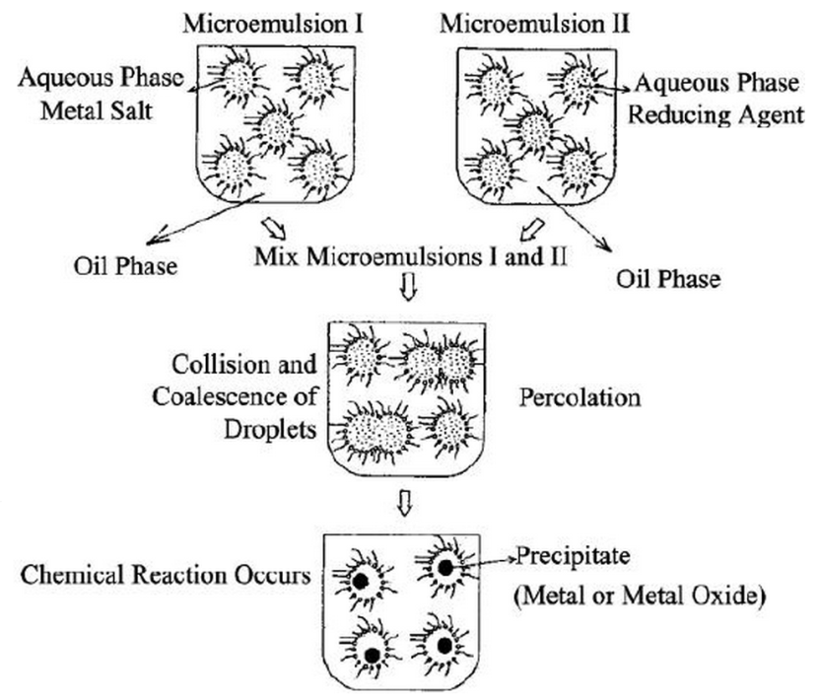
As in the binary systems (water/surfactant or oil/surfactant), self-assembled structures of different types can be formed, ranging, for example, from (inverted) spherical and cylindrical micelles to lamellar phases and bicontinuous microemulsions, which may coexist with predominantly oil or aqueous phases.

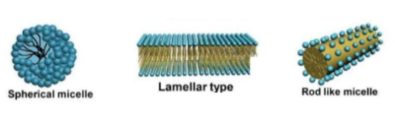
The advantages of microemulsion are:
- Degradation of proteins is effectively reduced due to the use of relatively mild conditions during the formulation process of microemulsions.
- Use of protein-compatible ingredients such as surfactants, water, and oils. These excipients are used in pharmaceutical formulations and generally recognized as safe. Their toxicities and metabolic profiles are well-known.
- Microemulsions are stable for relatively long periods.
- Microemulsions are recognized as a thermodynamically stable system.
- Microemulsion-based formulations are prepared in liquid forms, which are preferable for patients with difficulties in swallowing solids.
The disadvantages of microemulsion are:
- Microemulsion stability is influenced by environmental parameters such as temperature and pH.
- Limited solubilizing capacity for high melting substances.

- Hydrothermal Synthesis
Hydrothermal synthesis can be defined as a method of synthesis of single crystals that depends on the solubility of minerals in hot water under high pressure.
The crystal growth is performed in an apparatus consisting of a steel pressure vessel called an autoclave, in which a nutrient is supplied along with high temperature water. A temperature gradient is maintained between the opposite ends of the growth chamber. At the hotter end the nutrient solute dissolves, while at the cooler end it is deposited on a seed crystal, growing the desired crystal.
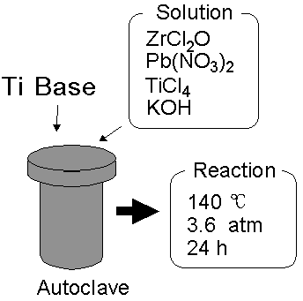
In hydrothermal synthesis temperature generally ranges from 130 to 250 C at high vapor pressure that generally ranges from 0.3 to 4 MPa. This technique has also been used to grow dislocation-free single crystal particles, and grains formed in this process could have a better crystallinity than those from other processes. There are two major methods according to whether or not use the specific surfactants. By hydrothermal synthesis it is conductive to prepare the unusual oxide nanostructures such as iron oxide nanocubes, iron oxide hollow spheres etc.
The advantages of hydrothermal method are:
- include the ability to create crystals which are not stable at the melting point.
- Also, materials which have a high vapour pressure near their melting points can be grown by the hydrothermal method.
- The method is also particularly suitable for the growth of large good-quality crystals while maintaining control over their composition.

The disadvantages of hydrothermal method are:
- the need of expensive autoclaves, and the impossibility of observing the crystal as it grows if a steel tube is used.
- There are autoclaves made out of thick walled glass, which can be used up to 300°C and 10 bar.
- Sonochemical Synthesis
Chemical reactions activated by powerful ultrasound radiation. The chemical effects of ultrasound arise from acoustic cavitation, that is, the formation, growth, and implosive collapse of bubbles in liquid. The implosive collapse of the bubble generates a localized hotspot through adiabatic compression or shock wave formation within the gas phase of the collapsing bubble. The conditions formed in these hotspots have been experimentally determined, with transient temperatures of 5000 K, pressures of 1800 atm, and cooling rates in excess of 1010 K/s. These extreme conditions were beneficial to form the new phase, and have a shear effect for agglomeration, which is prone to prepare the highly monodispersive NPs. Hence at very high temperatures with a very pressure hotspot generated by the rapid collapse of sonically generated cavities allows for the conversion of salts into nanoparticles. This method has been applied for the synthesis of various nanocomposites, and its versatility has been successfully demonstrated in different NPs preparation. For example, magnetite NPs can be simply synthesized by sonication of iron(II)acetate in water under an argon atmosphere.
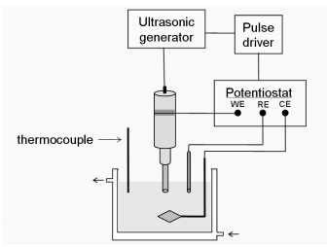
The advantages of hydrothermal method are:
- Accelerates the reactions & the growth of crystals.
- More uniform, smaller & purer crystals wih minimal agglomeration
- Single phase can be synthesis after 15-60 min sonication.
The disadvantages of hydrothermal method are:
- Disadvantages are in the form of long irradiation times and modest yields.
- Sol-Gel and forced hydrolysis techniques
The sol-gel process may be described as: ”Formation of an oxide network through hydrolisis and polycondensation reactions of a molecular precursor in a liquid.”
- Sol is a stable dispersion of colloidal particles or polymers in a solvent;
- Gel consists of a three dimensional network, which contains a liquid phase.
Sol-gel processing route is a wet chemical process for the synthesis of colloidal dispersion. The synthesis of metal oxides by sol-gel synthesis has proven extremely versatile since it allows the formation of a large variety of metal oxides at relatively low temperatures via the processing of metal salt as precursors. The structure and composition of nano oxides formed by sol-gel method depend on:
- The preparation condition
- The nature of the precursors
- The ion source
- pH
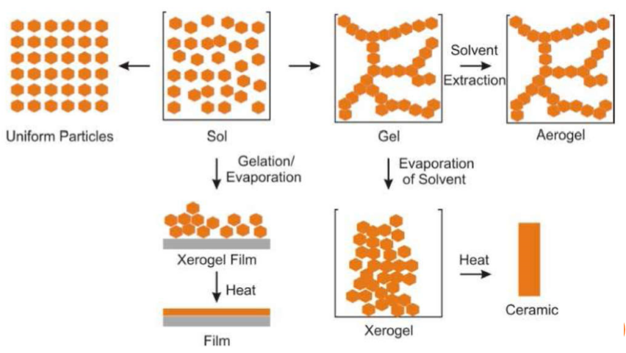
This process is based on the hydroxylation and condensation of molecular precursors in solution. Further condensation and inorganic polymerization lead to a three dimensional metal oxide network denominated wet-gel.
The advantages of sol-gel method are:
- tailor-made materials due to good process control,
- homogeneous multicomponent systems due to mixing in liquid medium,
- low temperature for materials processing.
The disadvantages of sol-gel method are:
- Expensive starting material.
- Difficulties in obtaining large scale monolits, free from crack.
- Sol-gel reactions are not reversible and impossible to completely inhibit.

- Electrochemical methods
In this method electrons act as reactant. The deposition of a metallic coating onto an object is achieved by putting a negative charge on the object to be coated and immersing it into a solution which contains a salt of the metal to be deposited (in other words, the object to be plated is made the cathode of an electrolytic cell).
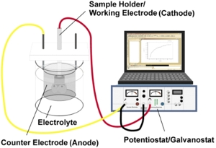

The advantages of electrochemical method are:
- It is an environmental friendly process with no pollution.
The disadvantages of electrochemical method are:
- the costly platinum is used as an electrode and not for reuse in aqueous solution.

- Aerosol/vapor methods
Aerosol technologies, such as spray and laser pyrolysis, are attractive because these technologies are continuous chemicalprocesses allowing for high rate of production.
- In spray pyrolysis, a solution of metal salts and a reducing agent in organic solvent is sprayed into a series of reactors, where the aerosol solute condenses and the solvent evaporates. The resulting dried product consists of particles whose size depends upon the initial size of the original droplets.
- Laser pyrolysis can be used to reduce the reaction volume. Laser heats the gaseous mixture of the precursor and a flowing mixture of gas producing small,narrow size, and non-aggregated nanoparticles. It is a well-studied method of obtaining NPs with particle sizes smaller than10 nm.Size of the nanoparticles could be controlled by:
- In-situ hard and soft laser decomposition of gaseous precursors in air
- Changing the initial ratio in the system

